EEW4 External Event Report

Title of the event: | EUFORES 20th Inter-Parliamentary Meeting on Renewable Energy and Energy Efficiency
Date & location: | 27 November 2020, Zoom Webinar
Organiser(s): | EUFORES
Summary of the event | On 27 November 2020, the 20th Inter-Parliamentary Meeting, IPM 20, took place online in the form of a zoom conference. The conference was also live streamed via YouTube on EUFORES YouTube channel. The event was attended by 121 participants, including Member of Parliament from 19 EU Member States. Other attendants of this conference included energy expert organisations, industry representatives, and the European Commission.  During the conference, speakers and panellists shared their thoughts on the Recovery and Resilience plans and how to use them to accelerate the energy transition and reach the EU 2050 climate neutrality target. The session on energy efficiency addressed the theme of creating new narratives to support the implementation of energy efficiency policies. With the objective to put the Renovation Wave at the centre of the Recovery and Resilience Plans.  Key Points of Discussion:  - The high-level opening session was dedicated to the opportunity the pandemic offers to redesign more sustainable economies that address the climate challenges and protect the health of citizens. Commissioner for Energy Kadri Simson, opened the conference with a key-note speech on the climate emergency, EU Green Deal and the Recovery and Resilience plans.  - Peter Sweatman talked about the one thousand bucket ready projects in renewable energy. He also made an interesting point that there is 17 trillion euros invested in buildings in Europe, 7 trillion of this are tight up in mortgages which amount to 10 trillion in equity. If the EU commission can borrow 0,3 percent imagine if we all could borrow at that rate how quickly we can bring about the transition we need.  - In her input, Maria da Graça Carvalho, MEP Portugal, stressed the need to involve citizens in the energy transition and to keep in mind the energy efficiency first principle. Niels Fuglsang, MEP Denmark and Vice-President of EUFORES, raised the importance of developing energy grids, and Ms Kadri Simson emphasised that for this, they will present a revision of the TEN-E in December.  - The last session on energy efficiency addressed the theme of creating new narratives to support the implementation of policies. To stir up the debate Deputy Manager of Upper Austria Energy Agency Christiane Egger, provided us with the findings of the Energy Efficiency Watch 4 Survey, with the result that energy efficiency is not well linked to the topic of job creation. We must therefore make our narratives stronger and more appealing.  - Commissioner from DG Energy, Carlos Sanches Rivero explained how the Renovation Wave communication was extremely timely because it is linked to the Recovery and Resilience Plans. We should see the tools available as an opportunity also loans and grants are important elements to cover the first costs and create a strong pipeline of projects and attract private investments in the renovation wave.  - Adrian Joyce from EuroAce, expressed his view on Europe saying it has the best policies toward energy efficiency in the globe, the challenge is to communicate scientific data capturing people’s attention. The jobs creation number generated from the renovation wave accounts to 1.6 million jobs, the numbers should be revised and raised in the communication documents.  - Monica Frassoni, President of EU-ASE explained that the criticism given to energy efficiency is that it is a long process, too costly and complicated. We must make the narrative more attractive and give more visibility to the technical assistance to implement the Recovery Package so that Member States can adopt it.  - MEP from Hungary Katalin Cseh explained how energy efficiency is necessarily politicized, we should depart from purely technical arguments and use arguments that are closer to people’s heart and make clear the advantages of the Green transition to the people.  - MEP Nicolas Gonzales Casares expressed how the narratives should be culturally specific. For Spain, the first narrative aspect for energy efficiency is saving money. But we need to better inform people about the benefit of saving emissions, this is a new narrative to explore.  - Cirian Ciuffe MEP from Ireland, concluded the session giving an overview of the debates on energy efficiency underlining the general agreement on getting out of our comfort zone to communicate energy efficiency in the best way to the broader public so that citizens will be at the core of the Renovation Wave. Among the narratives discussed, the most successful are about the creation of jobs and saving money some others are about the climate emergency and saving the world.
Objective & main programme point | The main objective was that to inform and activate MEPs and Mps on the latest stage of EE policies at European and National Level. Also, to provide an overview on the main challenges and developments of energy efficiency policies at national and their degree of implementation of European policies.
Conclusions | The event provided an overview on the current discussion on the EU Green deal and the Recovery and Resilience Plans and to make use of them to accelerate the energy transition and reach the EU 2050 climate neutrality target. The main priorities  regarding energy for the Recovery plans are to: power up, renovate, and recharge and refuel.  Overall, speakers agreed on the importance of cooperation and coordination among Member States to scale up cross border renewable energy projects and to involve citizens in the energy transition and to keep in mind the energy efficiency first principle.  Attendees asked for a change in the narratives to support energy efficiency policies. Improving the communication of energy efficiency will make the renovation wave more appealing to the Member States so that it will become central to the Recovery and Resilience Plans.  The PowerPoints are available here
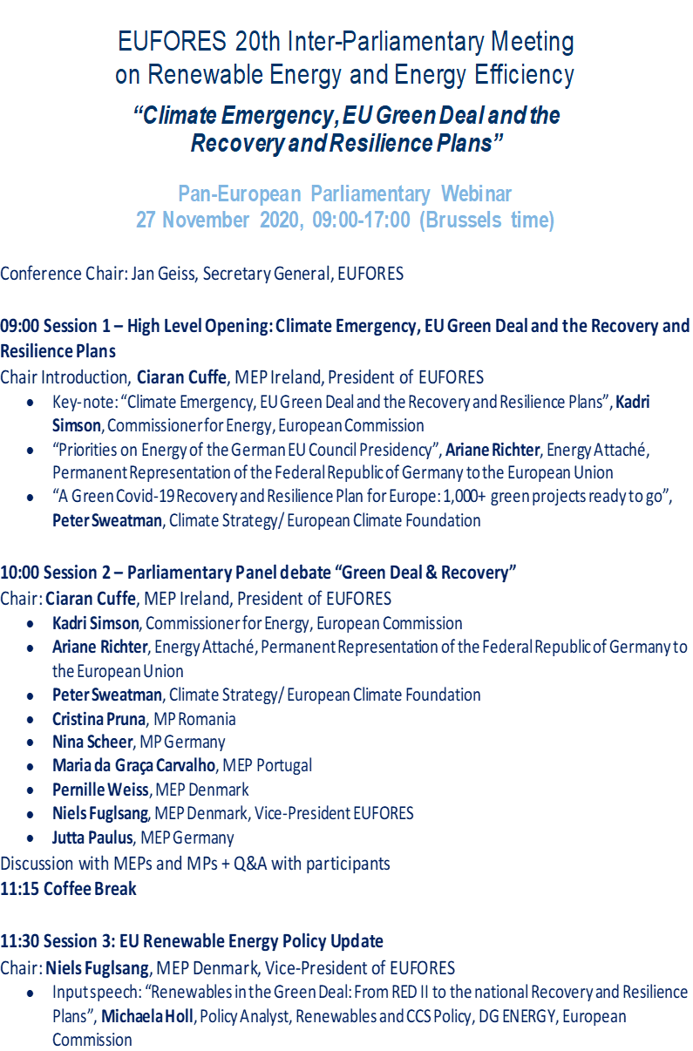
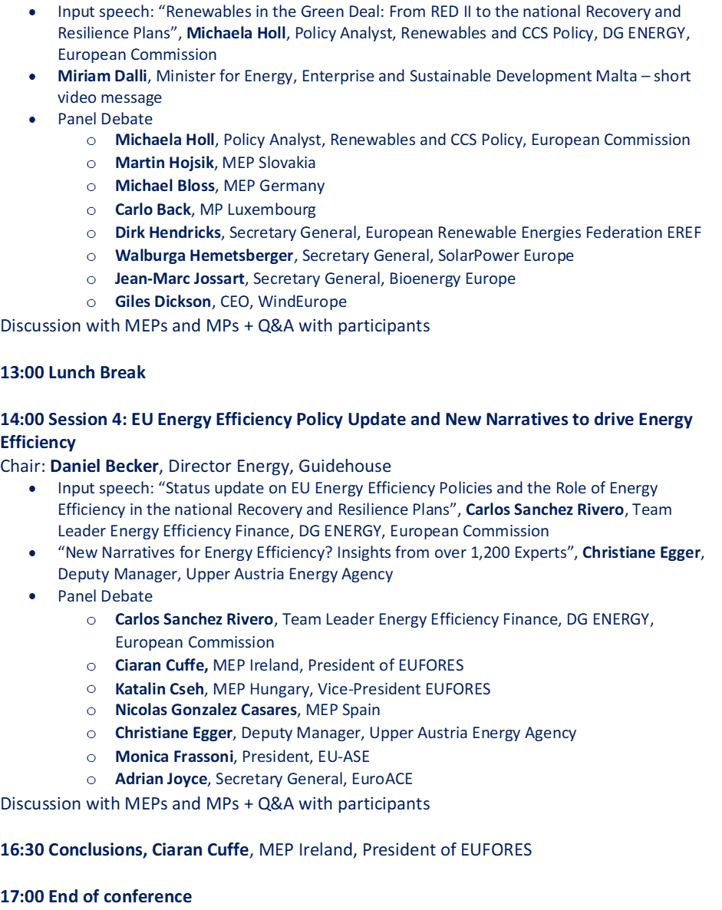
Pictures | 